**Experiment - 1.6(c)**

**Student Name: Milan Sharma UID: 23MAI10003**

**Branch: ME – CSE - AIML Section/Group: MAI – 1 (A)**

**Semester: 1st Date of Performance: 06 Sep 2023**

**Subject Name: Python Programming Subject Code: 23 CSH 623**

1. **Aim of the Experiment :**

Write a python program to concatenate two strings without using inbuilt function.

1. **Objective of the Experiment :**

To concatenate two strings without using inbuilt function.

1. **Algorithm/ Steps for Experiment**

Strings Joining of two or more strings into a single one is called concatenation.

1.        The + operator does this in Python. Simply writing two-string literals together also concatenates them.

2.        The * operator can be used to repeat the string for a given number of times.

1. **Code for Experiment :**

str1 = 'Hello'

str2 ='World!'

print('str1 + str2 = ', str1 + str2)

print('str1 + str2 = ', str1 + " " + str2)

print('str1 * 3 =', str1 * 3)

1. **Result/Output :**

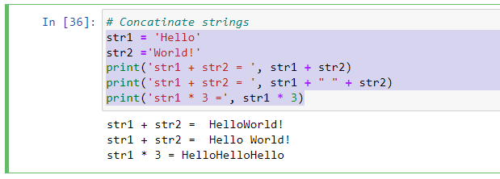

**Learning outcomes (What I have learnt):**

1. Learnt different operations performed on strings like concatenation finding position, finding the letters or string etc.

**Evaluation Grid (To be created as per the SOP and Assessment guidelines by the faculty):**

|  |  |  |  |
| --- | --- | --- | --- |
| **Sr. No.** | **Parameters** | **Maximum Marks** | **Marks Obtained** |
| **1.** | **Student Performance**  **(Conduct of experiment)**  **Objectives/Outcomes.** | 12 |  |
| **2.** | **Viva Voce** | 10 |  |
| **3.** | **Submission of Work Sheet**  **(Record)** | 8 |  |